1. Example of **count** meta argument when run with 3 new relic policies named example-policy-0 example-policy-1 ,example-policy-2

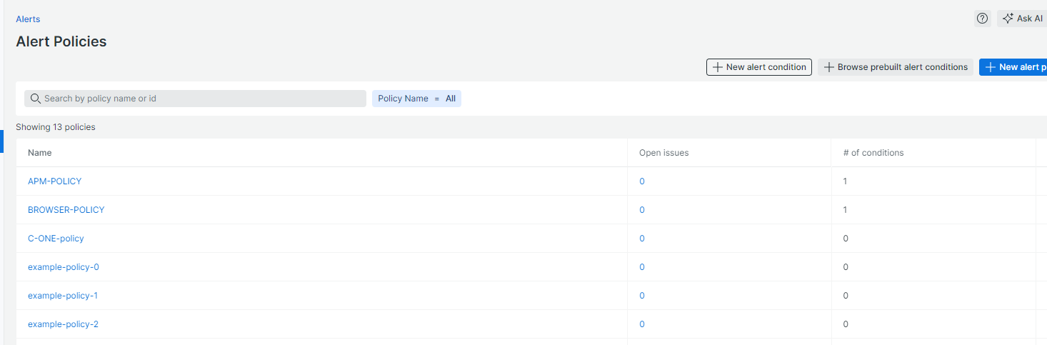

1. Example when we delete a policy from index 1, then policy at index 2 overrides policy 1, named example-policy-0, example-policy-1.

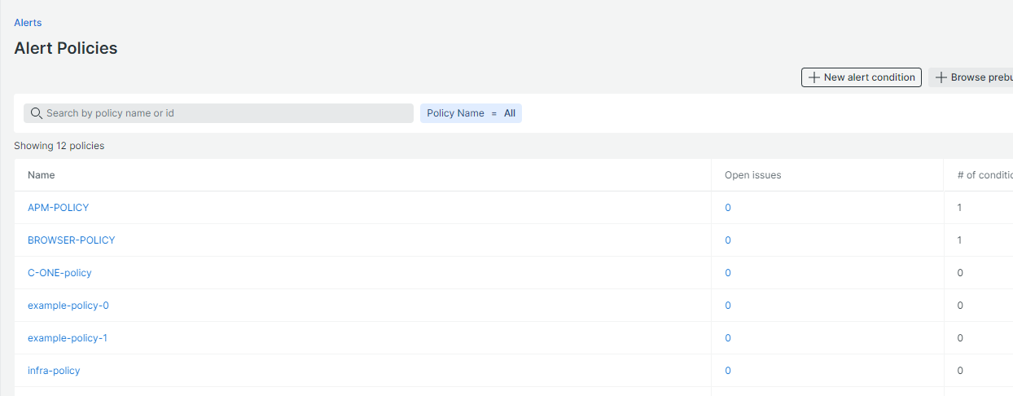

1. Example of **for-each meta** argument when we create 3 alert policy in new relic named examplee-policy-1, examplee-policy-2, examplee-policy-3.

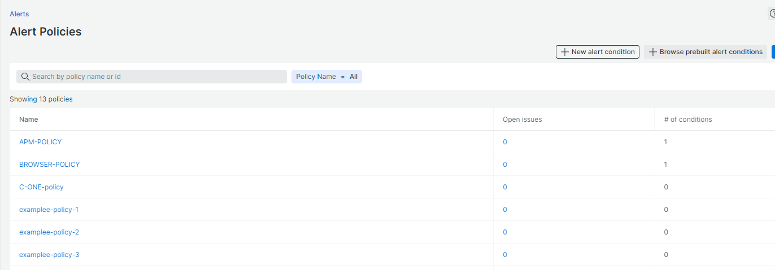

1. Example of foreach when we delete a policy at index 1, then index 2 will not override, it will stick to its index, hence index slicing will not be there

